# Blood Report Analysis and Consultation Chatbot Platform – MediWay

A

Minor Project (IS3270) Report

Submitted in the partial fulfillment of the requirements for the award of

Bachelor of Technology - CSE (IoT & IS)

By:

**Satyam Nautiyal**

**229302154**

Under the guidance of:

**Dr. G.L. Saini**



April, 2025

Department of IoT and Intelligent Systems

Manipal University Jaipur

VPO. Dehmi Kalan, Jaipur, Rajasthan, India – 303007

**DECLARATION BY THE STUDENT**

*I hereby declare that this project* ***MediWay*** *is my own work and that, to the best of my knowledge and belief, it contains no material previously published or written by another person nor material which has been accepted for the award of any other degree or diploma of the University or other Institute, except where due acknowledgements has been made in the text.*

Place:  **Satyam Nautiyal**

Date: 229302154

B.Tech CSE (IoT & IS) 6th Semester

***Department of*** ***IoT and Intelligent Systems***

***Manipal University Jaipur***

Dehmi Kalan, Jaipur, Rajasthan, India- 303007

**PROJECT COMPLETION CERTIFICATE**

**MINOR PROJECT (IS3270)**

Date: April 25, 2025

# *This is to certify that the work titled Blood Report Analysis and Consultation Chatbot Platform – MediWay submitted by Satyam Nautiyal ( 229302154 ) to Manipal University Jaipur in partial fulfillment of the requirements for the degree of Bachelor of Technology in CSE (IoT and Intelligent Systems), is a bonafide record of the Minor Project work conducted under my supervision and guidance from January 6, 2025, to April 25, 2025.*

**Dr. G.L Saini**

*Department of IoT and Intelligent Systems*

*Manipal University Jaipur*

**ACKNOWLEDGEMENT**

This project would not have been completed without the help, support, comments, advice, cooperation and coordination of various people. However, it is impossible to thank everyone individually; I am hereby making a humble effort to thank some of them.

I acknowledge and express my deepest sense of gratitude to my internal supervisor **Dr. G.L Saini** for his constant support, guidance, and continuous engagement. I highly appreciate her technical comments, suggestions, and criticism during the progress of this project **“Blood Report Analysis and Consultation Chatbot Platform - MediWay”**.

I owe my profound gratitude to ***Dr. Geeta Rani*** , Head, Department of IoT & IS, for her valuable guidance and for facilitating me during my work. I am also very grateful to all the faculty members and staff for their precious support and cooperation during the development of this project.

Finally, I extend my heartfelt appreciation to my classmates for their help and encouragement.

#### **Registration No.: 229302154 Student Name : Satyam Nautiyal**

**ABSTRACT**

The invention pertains to an AI-powered platform for automating the interpretation of medical diagnostic reports, such as blood tests and scan results, to make them comprehensible for non-medical users. Currently, medical reports contain complex terminologies and numerical values that require professional expertise to interpret. Patients often struggle to understand their test results, leading to delayed medical interventions, unnecessary anxiety, and an over-reliance on doctors for basic explanations. This invention aims to bridge this gap by leveraging Artificial Intelligence (AI), Optical Character Recognition (OCR), and Natural Language Processing (NLP) to extract, analyze, and generate patient-friendly summaries of diagnostic reports.

The tool enables users to upload their medical reports in PDF or image format, after which OCR extracts textual information. The system then processes the extracted data using NLP models to generate human-readable explanations, providing insights into abnormal values, potential health implications, and recommended next steps. The solution also includes interactive visualizations to help users better understand their health status. Additionally, it features a chatbot that allows users to ask follow-up questions about their reports, ensuring a more interactive and informative experience.

This innovation is particularly beneficial for remote healthcare, where access to doctors is limited. Patients in underserved regions or those using telemedicine services can receive preliminary insights into their health conditions without immediate professional consultation. The tool enhances healthcare accessibility, reduces the burden on medical professionals, and empowers individuals to take proactive measures regarding their health.

Existing medical report management systems focus primarily on storing, retrieving, and sharing reports rather than providing direct interpretation. While some AI-driven healthcare solutions exist, they are either highly specialized (e.g., predicting disease risks) or require extensive clinical validation before use. In contrast, this invention differentiates itself by combining OCR, NLP-based explanations, and chatbot integration into a single, user-friendly platform tailored for laypersons.

**TABLE OF CONTENTS**

Declaration by the student i

Project Completion Certificate ii

Acknowledgement iv

Abstract v

List of figures vii

List of tables viii

1. Introduction 1
2. Problem Statement 3
3. Literature Review 4
4. Project Description 6
5. Working Methodology 9

Conclusion

Future Work

Bibliography

**LIST OF FIGURES**

| **Figure No.** | **Title** | **Page Number** |
| --- | --- | --- |
| Figure 1 | System Flowchart | 7 |
| Figure 2 | Sequence Diagram | 8 |
| Figure 3 | System Architecture Diagram | 8 |
| Figure 4 | Home Page UI | 16 |
| Figure 5 | Signup Page UI | 16 |
| Figure 6 | Login Page UI | 17 |
| Figure 7 | Input Design – Context Form & PDF Upload | 17 |
| Figure 8 | Output Design – Extracted Blood Values | 18 |
| Figure 9 | Output Design – AI-Generated Insights | 18 |
| Figure 10 | Follow-Up Query Section | 19 |

**LIST OF TABLES**

| **Table No.** | **Title** | **Page** |
| --- | --- | --- |
| Table 1 | OCR Accuracy Comparison across PDF Report Formats | 13 |
| Table 2 | Semantic Similarity Scores for Different LLMs (SBERT Evaluation) | 14 |

**INTRODUCTION**

#### Medical test results such as scans and blood tests are usually professional-level and hard for non-medical practitioners to understand. Conventional medical systems do not have technologies that simplify complicated results into easy language. Secondly, patients seldom gain actionable advice and health planning insights from such tests.

#### MediWay addresses these issues with an AI-powered, interactive explanation of reports. MediWay uses OCR to pull and analyze data from medical reports and provides human-readable explanations using large language models (LLMs). MediWay also includes financial-grade data security, interactive visualization, and health tracking capabilities. Unlike PDF-based static platforms, MediWay provides dynamic, personalized data, lifestyle modification recommendations, and the capability to respond to follow-up questions through a chatbot. MediWay enhances healthcare literacy and allows users to make informed decisions about their well-being.

#### **Objective of the project**

1. Simplify Interpretation of Medical Reports to Laymen

* Create a safe cloud-based infrastructure intended to protect sensitive health data.
* Utilize health timelines and progress charts to facilitate long-term monitoring.
* Minimize reliance on outside experts for overall understanding of reports.

2. Foster Health Awareness and Preventive Care

* Offer individualized recommendations pertaining to lifestyle options or sustained support to address or avert health-related issues.
* Customize monitoring of diagnostic processes by age to identify trends in health outcomes.
* Assist patients' preparation for consultations by providing assistance with support questions and clarifications.

3. Protect Confidentiality and Enable Smart Health Monitoring

* Create a safe, cloud-based platform for safeguarding sensitive health information.
* Align health timelines and progress charts to facilitate long-term tracking.
* Minimize dependency on external experts for basic comprehension of reports.

## **Technology used**

* **Optical Character Recognition (OCR) & Data Extraction:** Tesseract OCR for extracting text from PDFs and images, pdfplumber for PDF parsing and text extraction
* **Natural Language Processing (NLP) & AI:** For medical term recognition and analysis and generating simplified health summaries.
* **Machine Learning (ML):** Pre-trained AI models (qwen-2.5-coder-32b) for text summarization and medical report interpretation.
* **Web Frameworks:** Flask for backend API, Streamlit for user interface, FastAPI for lightweight API development.
* **Database Management:** SQLite for storing predefined normal medical ranges and user history.
* **Cloud Deployment:** AWS / GCP / OCI for scalability, storage, and accessibility.
* **Security & Authentication**: Streamlit native auth with JWT and hashed credentials
* **System & API Integration:** OS for file handling, Requests for API communication, JSON for structured data exchange.

##### **Hardware Requirements**

• Processor: Minimum Intel Core i5 / AMD Ryzen 5  
• RAM: Minimum 8GB, recommended 16GB+  
• Storage: Minimum 1GB free disk space  
• Internet: Minimum 10 Mbps, recommended 50+ Mbps for cloud-based inference and API interactions

##### **Software Requirements**

* **Operating System**: Windows 10
* **Programming Language**: Python 3.8+
* **Libraries & Frameworks**:
* Data Handling & Manipulation: Numpy, Pandas
* PDF Processing & OCR: pdfplumber, pytesseract, pdf2image
* Image Processing: Pillow
* AI & NLP Integration: Groq
* Web Frameworks & APIs: FastAPI, Flak, Streamlit
* Database Management: SQLite
* File & System Operations: os, json
* **Cloud Services**: AWS S3, Google Cloud Storage, Oracle Cloud Infrastructure for scalable deployment

## **Problem Statement**

Medical diagnostic reports include technical jargon and quantitative information that needs some degree of professional expertise for proper interpretation. Patients usually find it difficult to comprehend their test results, and this causes unnecessary stress, delay in seeking health care, and an undue reliance on health professionals for simple explanations. Health professionals are not within reach in rural or underserved areas, further limiting the ability of people to comprehend their health information. People in these areas also need to be consulted in their Native languages making it yet more difficult for them and especially the elderly to shift to the Technology based solutions.

Also, current AI-based healthcare solutions either are centered on clinical decision support for physicians or provide static explanations without personalized insights derived from an individual's own health profile and medical history. There is no such widespread system yet that actively involves users, takes their health history into account, and provides them with real-

time personalized health information.

The invention met these challenges by:

1. Medical information recovery from photographs and PDFs using Optical Character Recognition (OCR).

2. The use of Natural Language Processing (NLP) to create comprehensible explanations tries to explain confusing medical terminology.

3. Allowing a Family view where members of a family can view the reports of each other, making health tracking easier.

4. Providing user-context based dynamic responses while taking factors such as age, weight, height, illness history, and symptoms into consideration.

5. Enabling interactive follow up consultations with a chatbot to resolve their queries and receive contextually appropriate answers.

6. Allowing Conversation in Native languages like Hindi, making it useful to a wider segment of the population.

By providing personalized, AI-based medical information to patients, this technology removes the dependency of doctors on premature reports and enables users to make well-informed health choices.

**Literature Review**

Artificial intelligence (AI) has revolutionized the healthcare industry through innovation in patient empowerment, medical information management, and self-service medical data. Artificial intelligence-based systems, such as chatbots and data scrapers, are revolutionizing access and the form of health delivery.

*CN104254863A (Inventors: Liu Hong, Fang Xiaoyun)* accounts for an AI-powered healthcare system for mobile that assists diagnostics based on patient inputs and contextual information. Once again, the focus here is more on symptom-based diagnosis and less on interpreting formal diagnostic information such as the findings of blood tests. MediWay, however, is designed to interpret such formal reports and translate them into layman-friendly, personalized narratives.

*US10834026B2 (Inventors: Jeremy Jordan, Giorgi Kvernadze, et al.)* Introduces a smart health system that offers suggestions that change dynamically with user input and therefore offers quality personalized insights. But it is intended primarily for general management of health and not for report-specific, in-depth diagnostic analysis provided by MediWay. Also, it does not upload diagnostic reports and process them with OCR and NLP workflows.

*US20220231985A1 (Inventors: Zachary Abzug et al.)* talks about a chatbot platform that utilizes real user data for real-time interaction and response customization. While it is real-time analysis-focused, it is far from the full extent of structured report analysis and interpretation offered by MediWay. Further, it does not offer integration with PDF-formatted lab reports or scans.

*US20250046448A1 (Inventors: Aravind Krishnan, Ayush Tyagi)* suggests a system that utilizes OCR and NLP to convert medical records, including diagnostic reports. This is quite in keeping with MediWay's approach; however, the patent is more on raw extraction and visualization. MediWay, by contrastm superimposes personalized explanations and interpretations of such records, so that users can understand their health information in context meaningful to their profile (age, gender, medical history, etc.).

**MediWay introduces the following key advancements to overcome the shortcomings of existing systems:**

* **Patient-Specific Explanation of Diagnostic Reports**

Unlike prior art which provides general healthcare responses or static diagnostic interpretations, MediWay uses a personalized approach to convert blood test values and scan results into intuitive narratives. The narratives generated are unique and personalized to every user by using the user context and health background information.

* **OCR-Driven PDF Report Ingestion**

MediWay lets users upload diagnostic report PDFs and uses Optical Character Recognition (OCR) to extract structured medical information, even from scanned or image-based files. This end-to-end integration from file to analysis is more comprehensive than the systems described in existing patents.

* **Natural Language-Based Interpretations**

Through the integration of large language models (LLMs), MediWay not only retrieves data from diagnostic reports but also generates explanations in conversational and comprehensible formats. This enables patients to engage meaningfully with their health data without needing a medical professional to interpret the results.

* **Interactive Health Assistant with Learning Feedback Loop**

MediWay also has a chatbot-based interface and provides interactive question-and-answer functionality, and it can fine-tune its responses based on user feedback and therefore become more intelligent and context-sensitive over time. This feature of ongoing learning is absent in the systems described above.

## **Project Description**

The **MediWay Medical Report Interpretation System** uses two main components:

### **Medical Report Analysis Engine**

At its core is a state-of-the-art medical report analysis engine that methodically parses diagnostic reports, scans, and blood tests to extract and analyze critical health metrics. It employs sophisticated Optical Character Recognition (OCR) and structured parsing methods to extract critical information, including test IDs, numerical values, and reference ranges from uploaded PDF files.

This information pulled is compared to standard medical reference points and user context (e.g., age, gender, medical history) to determine whether results fall within normal or alarming parameters. The analysis engine is very accurate by supporting multiple report formats and using domain-specific logic to interpret complex medical terminology.

### **LLM-Powered Explanation Module**

To improve health literacy and patient empowerment, MediWay integrates a Large Language Model (LLM) Explanation Module. Once the analysis engine processes the raw data, the LLM contextualizes it and generates natural-language summaries tailored to each user.

As an example, if you have high blood sugar, the LLM tells you what that is in plain language, possible health consequences (e.g., diabetes risk), and suggested next actions (e.g., diet modification, re-testing). The explanations are more than raw numbers, providing emotional comfort, caution, or preventive advice where appropriate.

The system follows a three-step workflow:

1. **Upload & OCR**: The user uploads a diagnostic report, which is scanned and converted into structured data.
2. **Analysis & Interpretation**: The analysis engine matches extracted data with reference ranges and user metadata.
3. **LLM Explanation & Visualization**: The LLM module generates personalized explanations, which are presented alongside interactive charts in a **Streamlit** dashboard.

This ensures an intuitive, informative, and interactive experience for users who wish to understand their health reports without needing professional interpretation.

Figure 1: Flow Chart –

This flowchart illustrates the step-by-step workflow of the MediWay system, starting from user login and medical report upload to OCR extraction, LLM-based analysis, and chatbot-enabled follow-ups. It highlights conditional branching based on OCR success and subsequent data processing for AI-driven insights.

Figure 2: Sequence Diagram –

The sequence diagram shows the interaction between various system components like the web interface, OCR, NLP processing, database, Flask API, and LLM chatbot. It maps how a user's uploaded report is processed and how summarized explanations are returned in response to analysis requests.

Figure 3: System Architecture Diagram –

This architecture diagram presents the high-level structure of the MediWay system, showcasing the integration of frontend (Streamlit), OCR, SQLite database, FastAPI backend, LLM API (Grok), and chatbot module. It reflects the data flow from user input to insight generation and interactive feedback.

**Working Methodology**

**Data Extraction & Preprocessing**

The MediWay system begins its core functionality with the extraction of medical parameters from PDF-based blood test reports. This process is crucial for enabling contextual interpretation by the LLM.

**OCR Techniques**

Optical Character Recognition (OCR) is performed using Tesseract OCR, an open-source engine known for its multilingual capabilities and high customizability. The PDFs are converted into images (using libraries like `pdf2image`), and each image undergoes OCR processing to extract text.

The extracted text is then passed through a preprocessing pipeline:

- Line Cleaning: Removal of header/footer noise (e.g., hospital branding, disclaimers).

- Regex Matching: Regular expressions are used to identify patterns such as:

- Medical parameter names (e.g., "Hemoglobin", "Cholesterol")

- Corresponding values (numerical and textual)

- Units (e.g., "g/dL", "mg/dL")

- Table Extraction: If the report contains structured tabular data, the system attempts to preserve and extract columns properly using line detection and cell grouping heuristics.

**Challenges with Non-Standardized Report Formats**

One of the primary challenges is the lack of standardization across labs. Different labs use various templates, fonts, orientations, abbreviations (e.g., "HB" for Hemoglobin), and positioning. This can lead to OCR misreads and incorrect mapping of values. Some common challenges include:

- Split lines or overlapping fields

- Multi-column layouts with misaligned headers

- Units embedded within parameter names

**Strategies for Structured Output**

To enable clean downstream processing, the extracted data is converted into a structured dictionary format:

json

{

"Hemoglobin": {"value": 12.5, "unit": "g/dL"},

"RBC": {"value": 4.5, "unit": "million/uL"},

...

}

```

Parameter aliases (e.g., "HB", "HGB") are normalized using a synonym dictionary. This standardization ensures consistency in how medical concepts are fed to the LLM for analysis.

**Prompt Engineering Strategy**

The Large Language Model (LLM) component relies heavily on precise prompt engineering to deliver accurate and understandable medical explanations. Prompts serve as the bridge between raw lab data and patient-friendly narratives.

**Prompt Crafting Approach**

The core strategy is to create prompts that are:

- Context-aware: Include the patient's basic info (age, gender, symptoms if provided)

- Concise yet descriptive: Avoid overwhelming the model with redundant data

- Medically guided: Ask the model to explain the implications of the results in simple language

**Zero-shot vs Few-shot Prompting**

We experimented with:

- Zero-shot: Giving the LLM only the extracted data and a single instruction like:

> "Explain this patient's blood report simply for a non-medical person."

- Few-shot: Including 1–2 examples of input-output pairs before the actual data.

Few-shot prompting showed marginal improvements in consistency, especially in generating warnings for abnormal ranges. However, zero-shot performed well with carefully tuned instructions.

**Sample Prompt:**

You are a medical assistant. The following is a blood report of a 35-year-old male:

- Hemoglobin: 11.2 g/dL

- WBC Count: 12,000 cells/uL

- Platelets: 160,000/uL

Please explain what these values mean in simple language. Mention if any values are concerning and what lifestyle or medical steps might help.

**OCR Output Filtering**

Before passing OCR output to the LLM, it is:

- Cleaned and deduplicated

- Mapped to standard medical names

- Reformatted into readable bullet points or JSON-style key-value pairs

This ensures the prompt is both clean and semantically rich for the LLM to interpret.

**Model Evaluation & Testing**

Evaluating a language model in the medical domain requires both technical and human-centric approaches.

**Evaluation Techniques**

1. Semantic Similarity: We use cosine similarity and embeddings (e.g., Sentence-BERT) to compare LLM-generated explanations with a set of reference explanations.

3. Edge Case Testing: Evaluating model output for abnormal values (e.g., critically low Hemoglobin) to ensure appropriate warnings are included.

**Ground Truth Consideration**

In future iterations, explanations will be vetted and enhanced by healthcare professionals, building a gold-standard dataset for supervised fine-tuning and stronger evaluation.

**Iteration Example**

- Bad Explanation: "Your hemoglobin is 11.2. It's okay."

- Improved Version: "Your Hemoglobin is 11.2 g/dL, which is slightly lower than the normal range for men. This could indicate mild anemia. Eating iron-rich foods or consulting a doctor may help."

Based on this, we refined our prompts to explicitly ask for causes and advice.

**Table 1 : OCR Accuracy Comparison across PDF Report Formats**

| **OCR Engine** |  | **Report Type** | **Accuracy (%)** | **Notes** |
| --- | --- | --- | --- | --- |
| Tesseract (Default) |  | Clean, Standard Format | 95.2% | High accuracy with single-column reports |
| Tesseract + Custom Config |  | Noisy/Scanned Report | 88.7% | Improved with DPI tuning and language hints |
| Tesseract + Preprocessing |  | Multi-column + Skewed Layout | 84.5% | Line splitting and table misreads common |
| Other Engines (EasyOCR, PaddleOCR) |  | Multi-language Support | 80.1% | Slightly better on reports with Hindi/English mix |

**Note:** Accuracy is calculated as the % of correctly extracted parameter-value-unit triplets over total valid entries.

**Table 2 : Semantic Similarity Scores for Different LLMs (SBERT Evaluation)**

| **LLM Model** | **Average Similarity Score ( out of 10)** | **Notes** |
| --- | --- | --- |
| **qwen-2.5-coder-32b** | **7.52** | Highest semantic match, strong reasoning ability |
| llama3-8b-8192 | 7.48 | Lightweight model, surprisingly high accuracy |
| qwen-2.5-32b | 7.45 | Robust explanation consistency |
| llama-3.3-70b-specdec | 7.43 | Good contextuality and medical phrasing |
| llama3-70b-8192 | 7.39 | Balanced output, effective in generic prompts |
| mistral-saba-24b | 6.92 | Tends to generalize more, needs precise prompts |
| gemma2-9b-it | 6.81 | Sometimes lacks medical depth |
| llama-3.2-11b-Vision-Preview | 6.68 | Vision support didn’t add much for text reports |
| deepseek-r1-distill-llama-70b | 6.39 | Occasionally generated oversimplified answers |
|  |  |  |

**Note:** Scores are averaged across 90 responses tested using Sentence-BERT cosine similarity with reference expert explanations. A higher score indicates stronger semantic alignment.

**User Experience (UX) Design**

The MediWay UI is built with Streamlit, chosen for its simplicity and fast prototyping capabilities. Our UX goals focused on clarity, minimalism, and responsiveness.

Key UX Design Principles

- Simplicity: Users upload a report, enter basic info, and instantly get insights.

- Readability: Explanations are styled with bullet points, highlights for abnormal values, and consistent formatting.

- Interactive Guidance: Users can hover or click on terms for detailed definitions (future feature).

**Accessibility Considerations**

- Contrast ratios suitable for low-vision users

- Text resizing via browser zoom

- Designed mobile-first with responsive layout for tablets/phones

**UI Walkthrough**

1. Homepage: It tells the basic features of the App and allows user to visit the Login / Signup form.
2. Signup / Login Page: Secure Signup / Login with native Streamlit Auth.
3. Form Section: Users enter their age, gender, and optional symptoms.
4. Upload Interface: Drag and drop a PDF report.
5. Result Page:

- Parameter table with values

- Natural language explanations (LLM output)

- Optional download of full report summary

These design decisions ensure MediWay remains not only powerful but also welcoming to non-technical, health-conscious users.

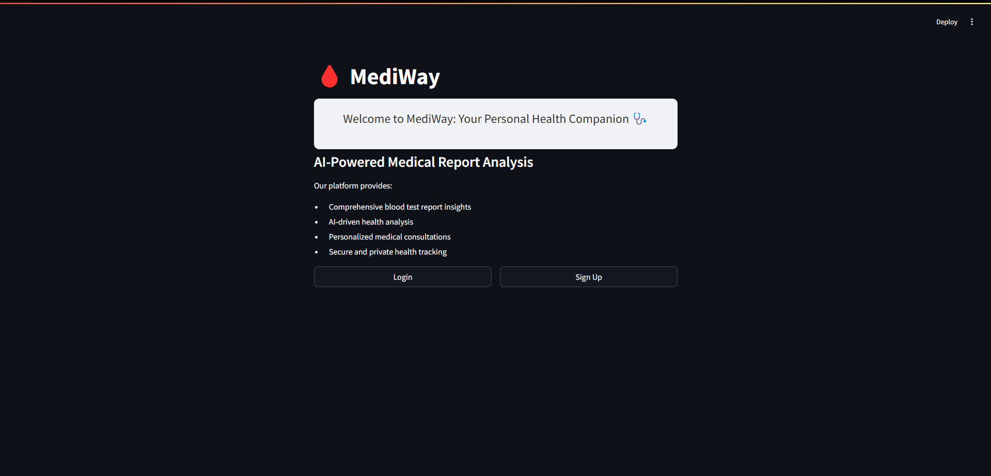

Fig 4: Home Page –

This image showcases the login interface of MediWay, allowing users to securely sign in using Streamlit’s built-in authentication. The clean UI provides an intuitive gateway for accessing personalized medical insights.

Fig 4.1: Signup Page –

Fig 4.2: Login Page

Figure 5: Input Design –

After successful login, users land on the MediWay dashboard where they can upload their blood test reports and enter basic health details. This streamlined interface simplifies data input and report submission.

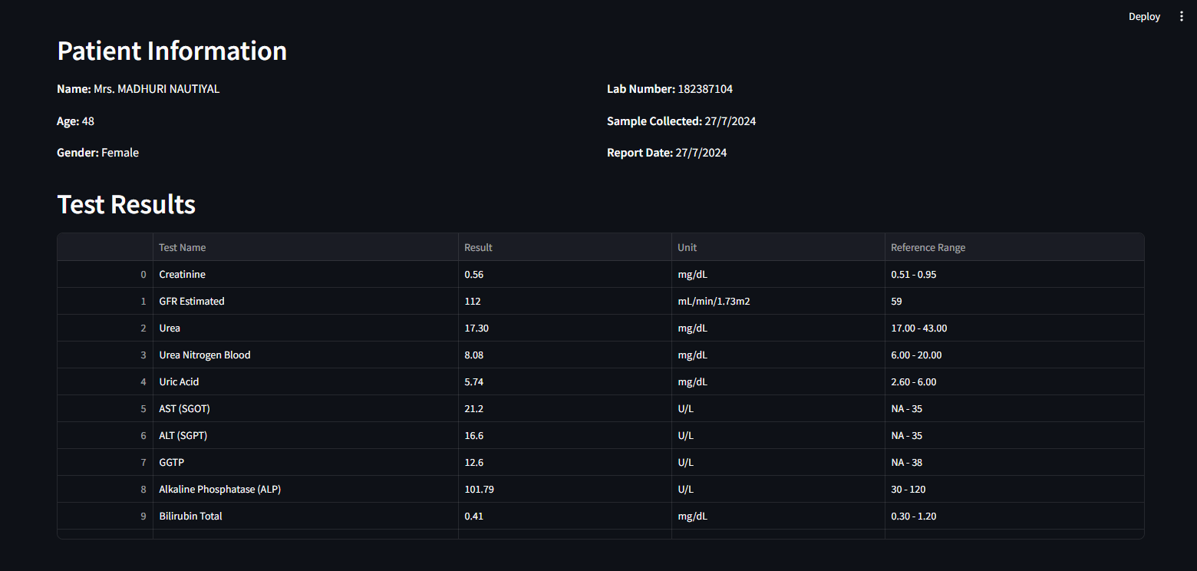

Figure 6: Output Design –

The uploaded medical report is displayed with extracted parameters automatically parsed using OCR. The system intelligently identifies and highlights relevant test results for analysis.

Figure 9: Output Design –

The platform generates patient-specific insights using LLM-powered analysis. Key parameters are explained in layman-friendly language, making it easier for users to understand their health condition.

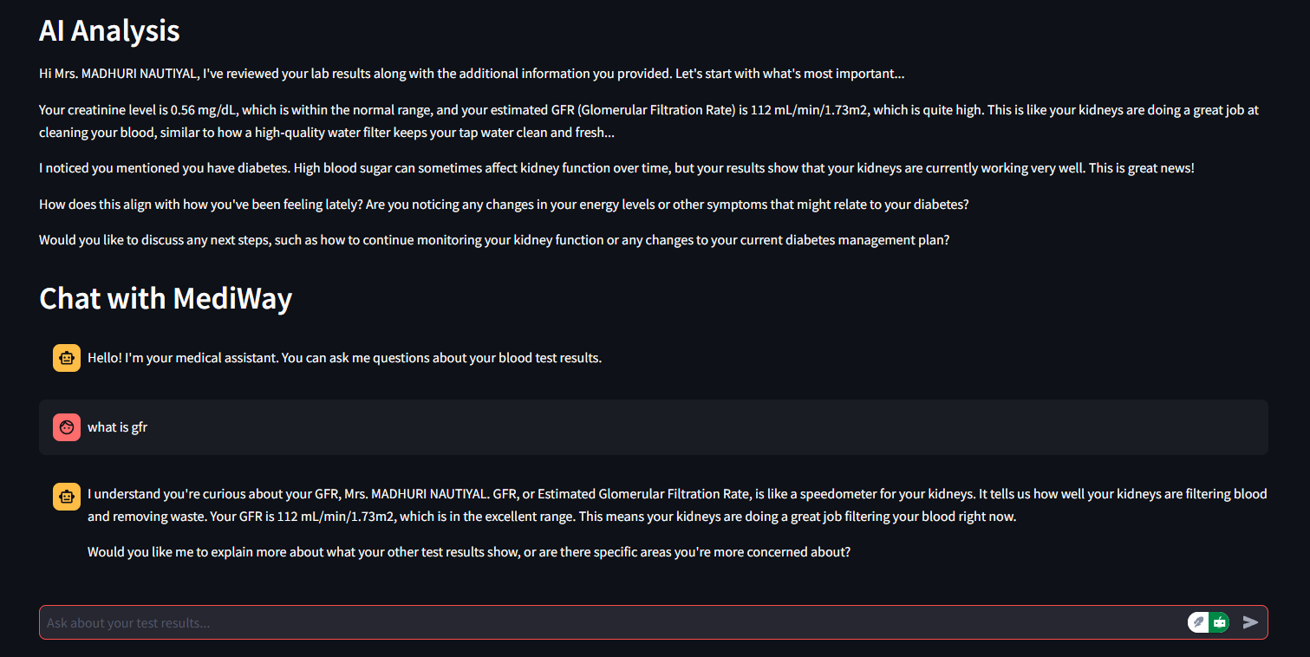

Fig 10: Follow Up Queries –

Users can interact with a medical chatbot to clarify doubts, ask follow-up questions, or receive explanations related to their health report. The chatbot leverages contextual LLM understanding to provide tailored answers.

#### **Conclusion**

MediWay is a milestone in democratizing healthcare knowledge through artificial intelligence. By transforming complex, technical blood report information into personalized, patient-centric narratives, it makes it easier for users—particularly non-expert users—to better understand their own health. It unites a variety of factors: high-performance OCR for parameter extraction from different report formats, structured preprocessing to normalize, and effective prompt engineering to guide large language models in supplying contextual medical data.

One of MediWay's most significant achievements is its ability to handle lab report heterogeneity. Through synonym normalization and pattern recognition, it traverses inconsistent nomenclature and structure to produce structured outputs in human-interpretable form. The prompt design strategy, tested across multiple LLMs and evaluated using semantic similarity scoring, ensures explanations are not just accurate but also understandable, actionable, and empathetic in tone.

The user interface has been specifically created with minimalism, simplicity, and mobile responsiveness in mind. Built on the Streamlit platform, the app simplifies the process: the users sign in to their account, enter the most crucial information, upload a report, and get instant explanations. The visual cues and accessibility features, such as color-coded values, optimize the system's usability and readability.

In the coming years, MediWay has vast growth potential. Adding expert-approved explanations, multilingual support, EHR connectivity, and powerful visualization tools can make it even more impactful. With these features, it can become a full-fledged AI-based assistant for preventive care and health monitoring.

In short, MediWay demonstrates how thoughtful artificial intelligence design—prioritizing transparency, inclusivity, and real-world needs—is capable of making healthcare information more transparent, personalized, and accessible to all.

**Future Work**

While MediWay successfully bridges the gap between clinical diagnostic reports and patient comprehension through AI-powered interpretations, there remain several key areas for future enhancement and expansion:

### 1. **Integration with Certified Medical Oversight**

To increase trust and clinical reliability, future versions of MediWay can integrate a review or approval mechanism by certified medical professionals. This hybrid human-in-the-loop approach will enhance the safety, credibility, and adoption of AI-generated insights.

### 2. **Multilingual and Regional Support**

Currently designed primarily for English-based reports, MediWay can be extended to support multiple Indian and international languages. This will ensure accessibility to non-English-speaking populations, especially in rural and semi-urban areas.

### 3. **Mobile App Development**

A dedicated Android/iOS app with optimized OCR and AI integration will increase accessibility and convenience, allowing users to scan reports using their phone cameras and receive instant insights.

### 4. **Integration with Electronic Health Record (EHR) Systems**

Future iterations may support direct integration with hospital EHRs, allowing real-time fetching and interpretation of diagnostic data without manual uploads. This will enable seamless and secure healthcare data flow.

### 6. **Health Risk Forecasting & Preventive Alerts**

By aggregating multiple reports and analyzing health trends over time, MediWay can evolve to provide early warnings, preventive care suggestions, or risk forecasting based on a user's health history.

### 7. **Explainability Dashboard for Medical Professionals**

An extended dashboard can be developed for doctors and caregivers to view the AI’s rationale and interpretation breakdowns, increasing transparency and aiding clinical decision-making.

**Bibliography**

## **Patent References**

1. **CN104254863A** – Liu Hong, Fang Xiaoyun. Mobile-based AI diagnostic system based on patient inputs and contextual data. Focuses on symptom-driven diagnostics rather than formal diagnostic report interpretation.
2. **US10834026B2** – Jeremy Jordan, Giorgi Kvernadze, et al. Smart health suggestion engine with dynamic personalization. Designed for general health management without OCR/NLP-driven report interpretation.
3. **US20220231985A1** – Zachary Abzug, et al. Real-time chatbot customization using user health data. Offers real-time interactivity, but lacks structured diagnostic report handling.
4. **US20250046448A1** – Aravind Krishnan, Ayush Tyagi. OCR and NLP-powered medical report digitization and visualization system. Focuses on raw data extraction and display without personalized interpretations or contextual health narratives.

## **Research Papers & Scholarly Articles**

1. ACM. **Chatbots as Conversational Healthcare Services**. Explores the role of chatbots in handling routine patient communication and easing practitioner workload.
2. IEEE. **Foundation Metrics for Evaluating Effectiveness of Healthcare Chatbots**. Proposes metrics such as user satisfaction, responsiveness, and clinical appropriateness to assess chatbot performance in healthcare.
3. IEEE. **Leveraging OCR and NLP Technologies for Improved Efficiency in Medical Data Collection**. Discusses how OCR and NLP reduce manual errors and enable efficient processing of diagnostic records.
4. IEEE. **Artificial Intelligence–Based Chatbots for Promoting Health Behavior Change**. Demonstrates the potential of AI in encouraging drug adherence and healthier behavior through tailored, interactive chatbots.